Safeguarding Against COVID-19

Spring Ridge’s Response & Helpful Resources
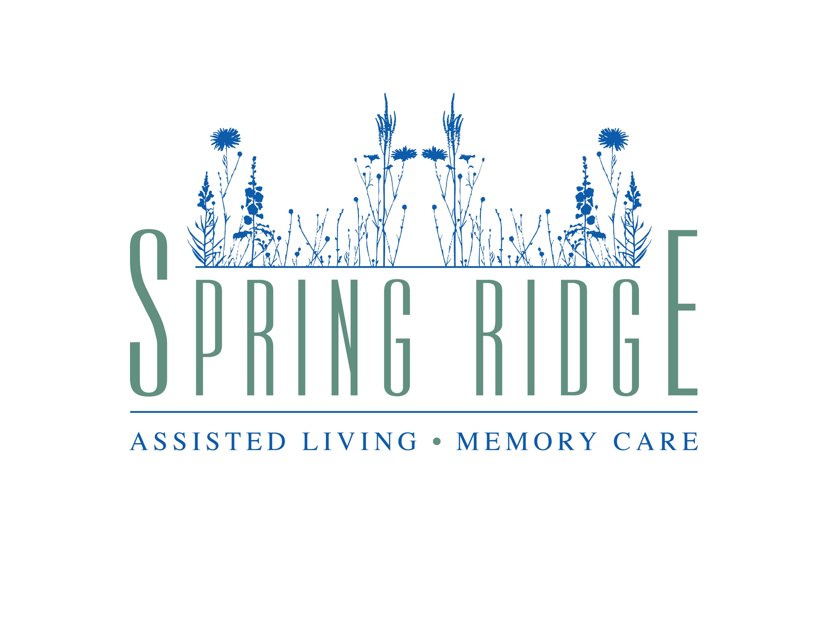
A message from our Community Leaders:
September 13, 2021
Hello all,
As we brave a second year of the COVID-19 pandemic, we continue to gain insight and best practices that aid the safety of our facilities. We are grateful for our staff and residents who have committed to getting vaccinated—as a whole, our community hovers at 95% of its residents being vaccinated. As of October 18th, 2021, health care personnel will be mandated by the state of Oregon to be vaccinated and we trust this will further ensure the safety of our staff and residents.
Since the start of COVID-19 in the early spring of 2020, we have found new trends to share with you regarding the impact of this virus within our community. Our statistics have demonstrated that a consistently high concentration of vaccinated residents has greatly diminished the severity of symptoms and subsequent death of residents who test positive for COVID in our communities. We have seen periodic positive cases either in staff or residents since visitation has re-opened and since residents have engaged in community activities. However, even if a vaccinated resident contracts COVID the overall symptoms of the illness have been greatly reduced and the duration of the illness has shortened. To us, this offers hope.
Families are being informed promptly if an outbreak occurs at our facility. Our Administration will personally reach out if residents are in contact with someone who has contracted COVID or if they personally contract COVID.
We promise to stay current, be responsive and remain vigilant to all county, state, and national health guideline updates. The state-of-the-art screening technology we have implemented in facility entrances will be ongoing, offering visitors, staff, and residents a continual safeguard against COVID-19. Thank you for your patience and grace during these times. Please seek out the answers to any of your COVID-19 questions with help from Spring Ridge Assisted Living and Memory Care’s Executive Director, Michelle Wyse. Thank you for your patience and grace during these times.
Sincerely,
Benicia Management
Our Response Efforts

- All team members and visitors will always wear masks (and/or gloves and eyewear when directed by health officials and guidelines).
- All team members and visitors will continue to observe standard appropriate contact and droplet precautions.
- All team members and visitors will continue to have their temperature and COVID-screening daily upon entering the facility.
- All resident’s temperatures will be taken at least once a day, in addition to their daily COVID-19 screening.
- Keeping signage current throughout the community regarding infection control protocol.
- Working with healthcare providers and partners in addressing unique care needs and monitoring.
- Posting signage on entryway doors to notify visitors that only those essential to the well-being of our residents may enter (including Hospice, Home Health, and other health care providers).
- Continually re-educating our team members on best infection control practices in managing daily tasks throughout our community (this includes, handwashing, increasing the frequency of disinfecting all surfaces, tools/utensils, with particular attention on high-touch surfaces such as handrails).
- Encouraging opportunities for residents to connect with families through video and other digital technologies when possible.
- Continue resident activities in accordance with health guidelines and maintaining social distancing in all circumstances unless offering direct care.

Safeguarding Against COVID-19

Spring Ridge’s Response & Helpful Resources

State Resources:

Washington State Department of Health

National Resources:

Center for Disease Control & Prevention

American Health Care Association

World Health Organization

